## **Background:**

In our food delivery services, there has always been some sore area with “small orders” – quantity. The cost of servicing those orders, the commission from the merchant , the delivery fee charged to the Customers and the subsequent fees paid to the dasher all put together had made servicing our esteemed customers efficiently.

*(“Small order” – one or two snack or light meal).*

The idea is to fully automate the delivery of all small orders, but for starters we would focus on small delivery from restaurants within a 2 miles radius of the customer. We would also make provision for the manual control of the Robo-dasher in any event the need arises.

Tracking a food order is the most important service a customer would need a CSR to perform. Our CSR/Ops. Team should be equipped with the tools to track an order in real time, pick-up status of the order, provide an accurate ETA of the Robo-dasher to delivery location. The application provides all these information to the CSR/Ops. Team that can be relayed to our customer, designed to provide this information in one place in a super-fast way.

The application is developed with the aim to help the CSR /Ops. Team personnel track the Robo-dasher in real time, check the Robo-dasher distance to the delivery location, confirm if the Robo-dasher has picked up the order, and provide an overview of the Robo-dasher.

*(“CSR/Ops. Team” – Customer Support Representative / Operations Team)*

## **Details:**

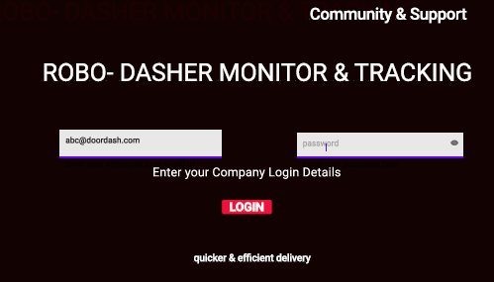

1. **How to Sign-in : Enter your Email and password and click on the Login in button , if you have an issue click on support**
2. **Click on the Track Location to help a customer track a Robo-Dasher**

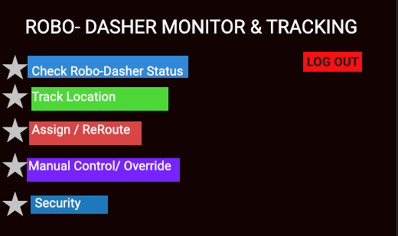

1. **Enter the Customer ID details and click on search**

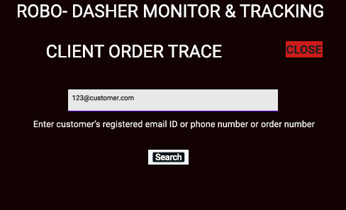

1. **The search results displays on this screen- info on order status and the Robo-Dasher ID is provided**

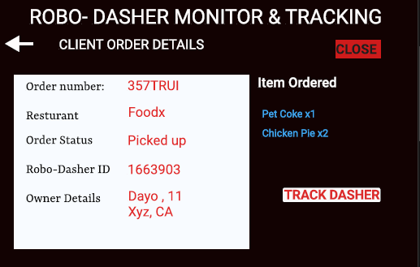

1. **Click on the search button to Track the Robo-Dasher.**

**The Robo-Dasher ID is also available on screen 4 of** [**Prototype**](https://www.figma.com/proto/474Zqi9gBJu94ix00xPIFX/ROBO-DASHER---V2?node-id=13%3A631&scaling=scale-down&page-id=0%3A1&starting-point-node-id=2%3A286) **and is automatically filled here**

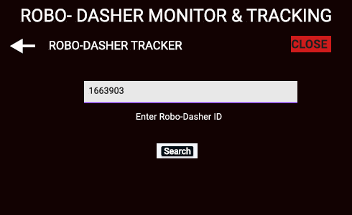

1. **Click on MAP to see map view of the Robo-Dasher location**

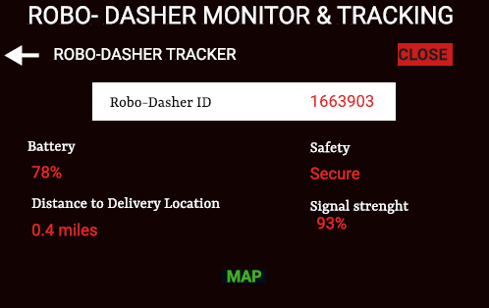

1. **Click on the buttons, to re-route, manual control or cancel as the customer need may require**

